Write about it NOW!

60 minute “whole” class activity: Strategies to complete a motivating activity and have the students write about it within a 60 minute time block – and keeping students ENGAGED!

WHAT AND WHY:
- In order to make strong progress, students need meaningful writing activities throughout the school day, not just during “writing time.”
- In order to want to write, students need to see a “reason” for writing.
- Waiting to write about an activity until the next day or even week (for Speech/Language Pathologists) decreases motivation (the novel experience is lost – been there done that)
- Student’s writing about an activity he/she just participated immediately reinforces the language that was focused on during the activity.
- Student’s take his/her writing home, reinforcing the language in the home setting.
- “……. the ability to read and write does not develop naturally, without careful planning and instruction. Children need regular and active interactions with print…..” http://www.readingrockets.org/article/learning-read-and-write-what-research-reveals

WHO IS THIS FOR:
As Speech/Language therapists, we need to have writing be part of our “therapy time.” Yet, this can be challenging due to our large caseloads and time constraints.

Often we ask questions such as these: “How can I keep a class engaged and wanting to participate in writing?” “How can I keep all the students’ engaged and learning while other student’s take his/her turn?” “How can I reinforce language I am teaching beyond the therapy session?”

HOW TO DO IT:
Sample lesson:
- If you have an iPad that can connect to a school computer/projector:
1. Take pictures of the students participating in an activity during the activity using the iPad.
2. Connect the iPad with a projector cable to project onto a smart board or white board.
3. Use the pictures taken in any electronic app you want to use, (e.g. story buddy, book creator, etc.) – see Spedapps2 wiki for ideas- https://spedapps2.wikispaces.com
4. The student can then write about his/her own picture participating in the activity. SO motivating for them! The other student’s are all engaged watching the other student writing since it is projected so all the class can see.

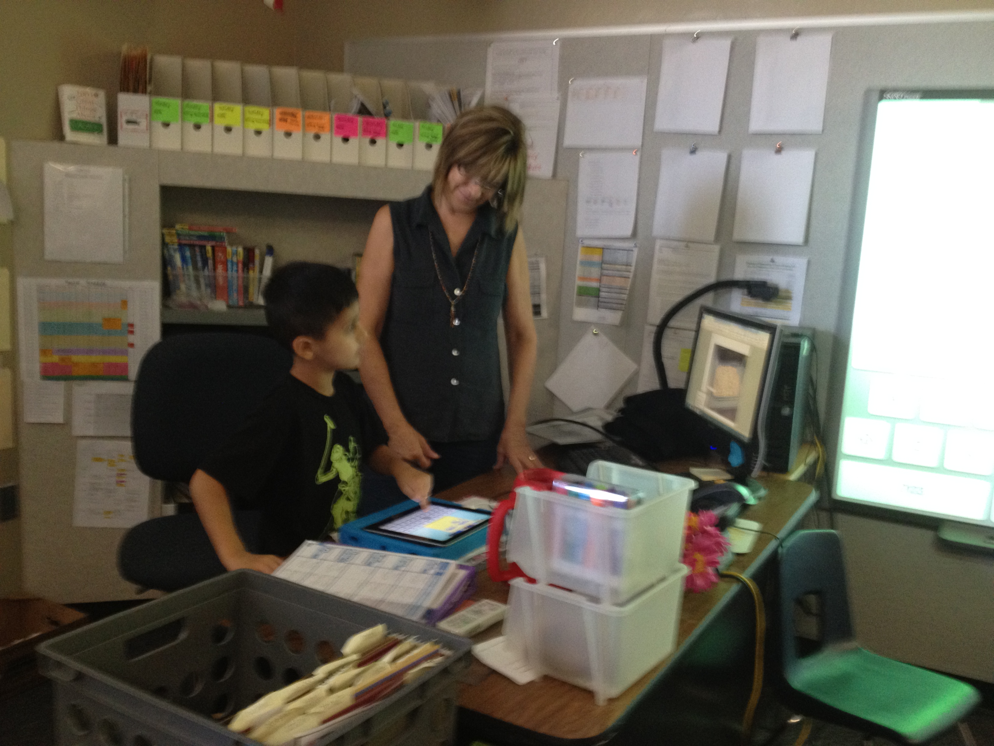
Writing about “noodles” activity – the student’s made noodles in prior session. The next session we ate them and talked/wrote about them.

If you DON’T have access to using an iPad

1. Take pictures of the student’s using your cell phone during the activity
2. Email the pictures to yourself
3. Open photos using a school computer that is projected onto smart board or white board
4. Open up a PowerPoint Document (all schools have this!)
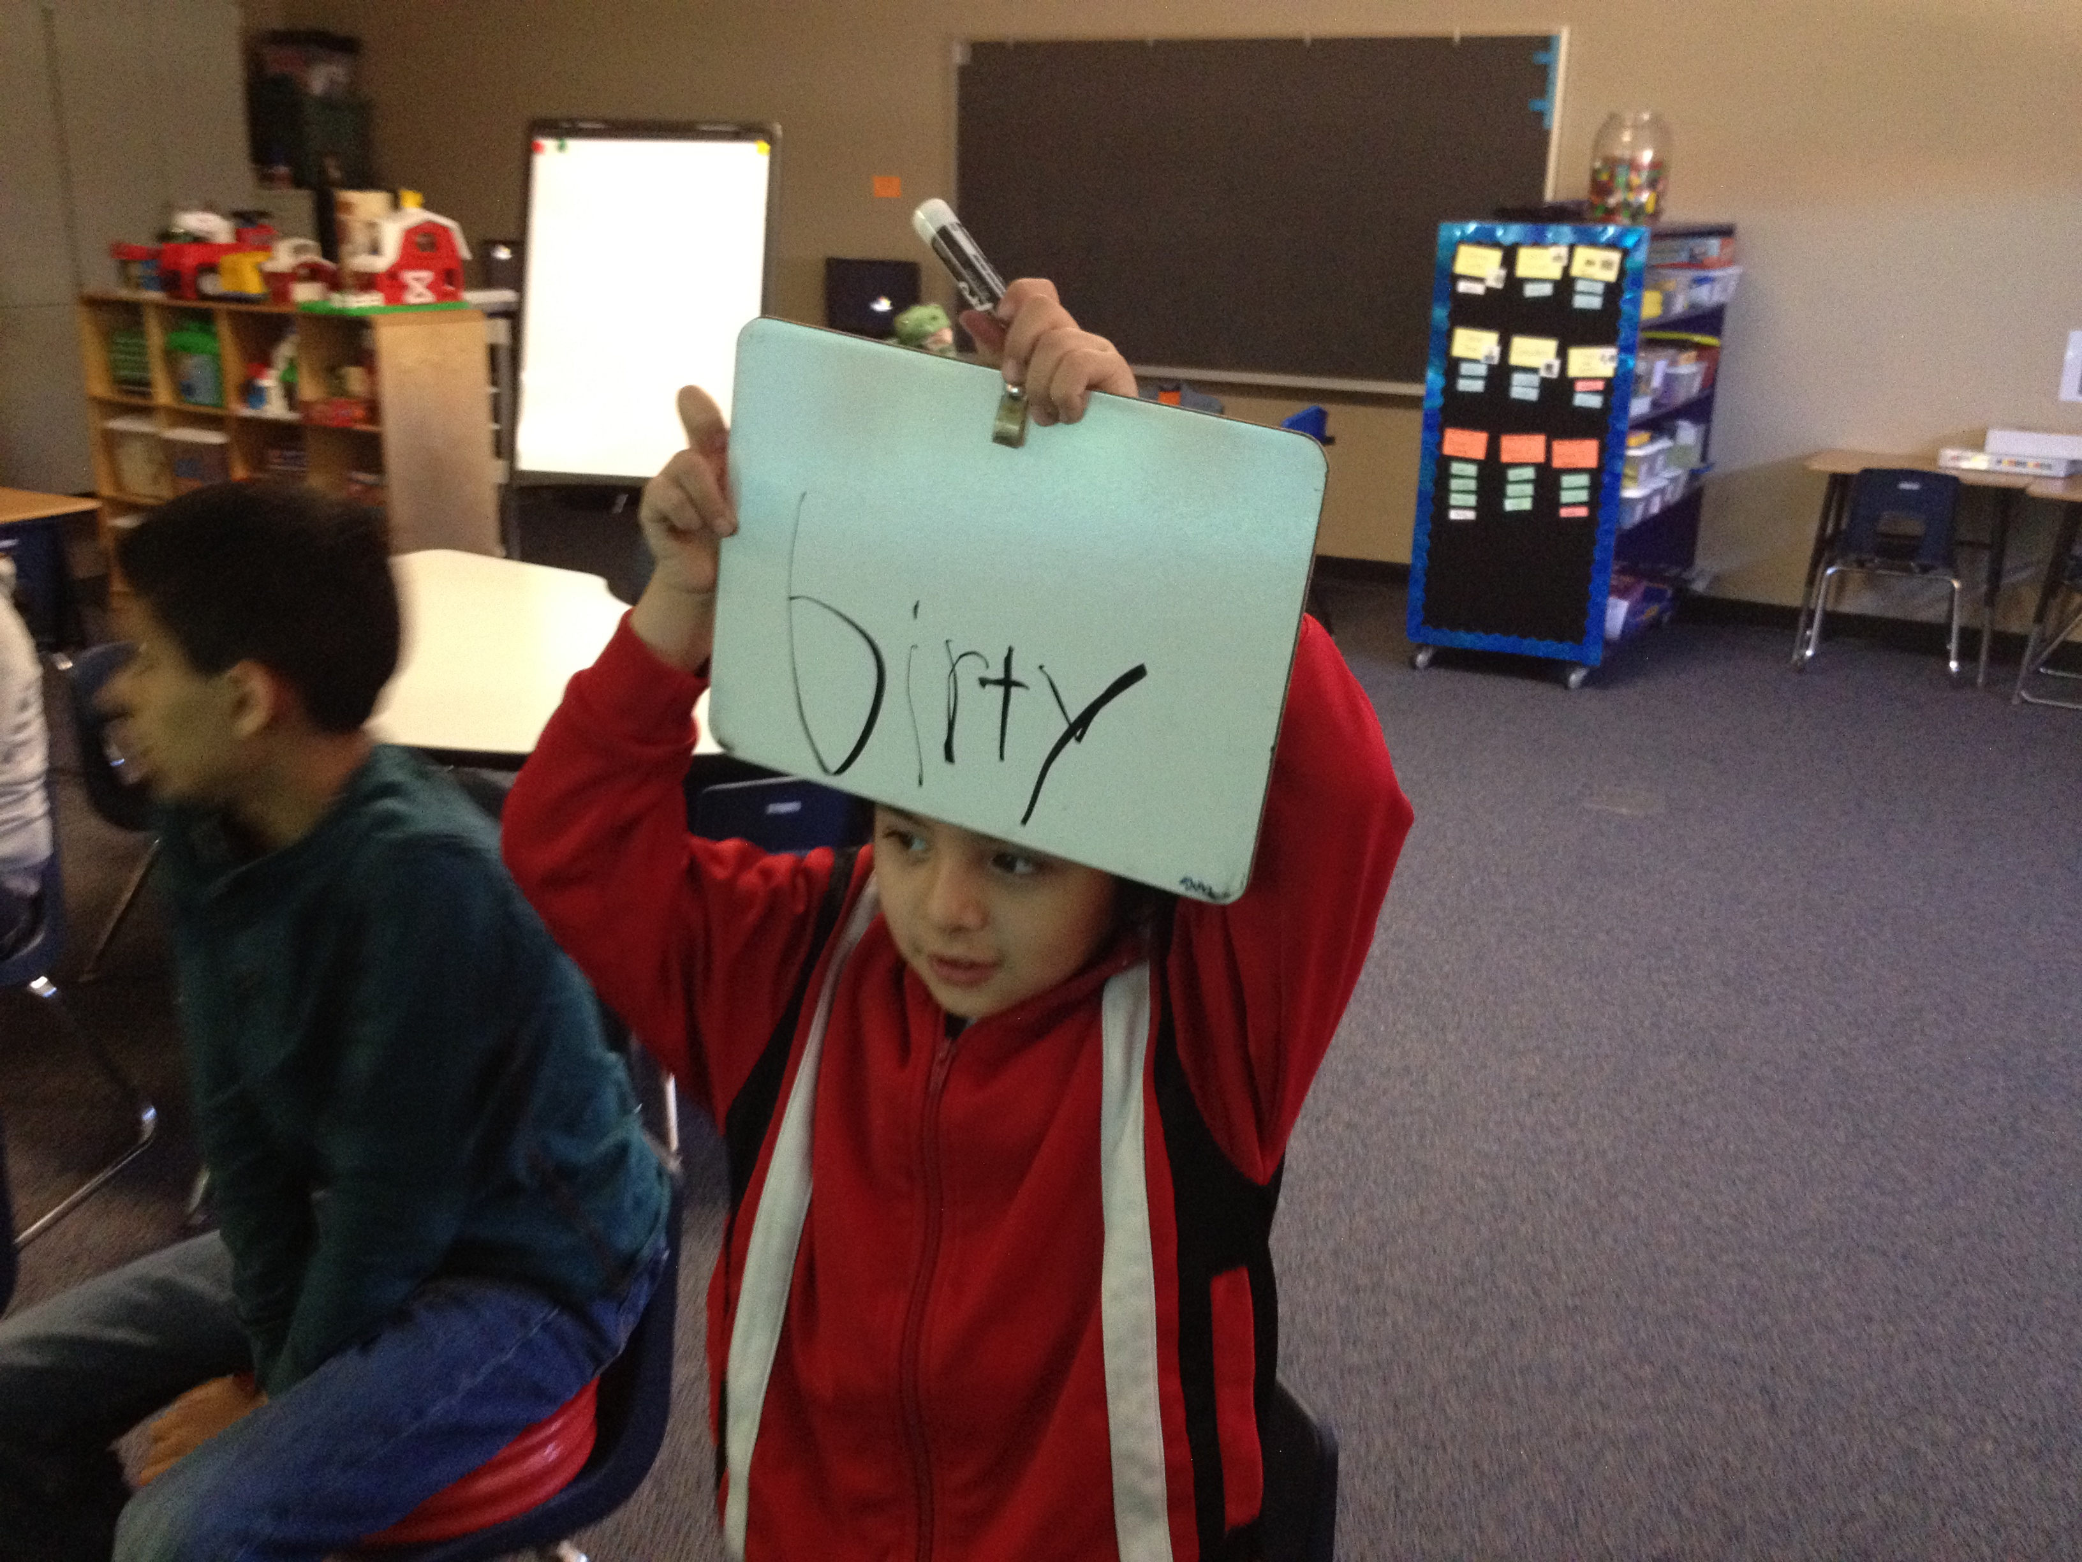
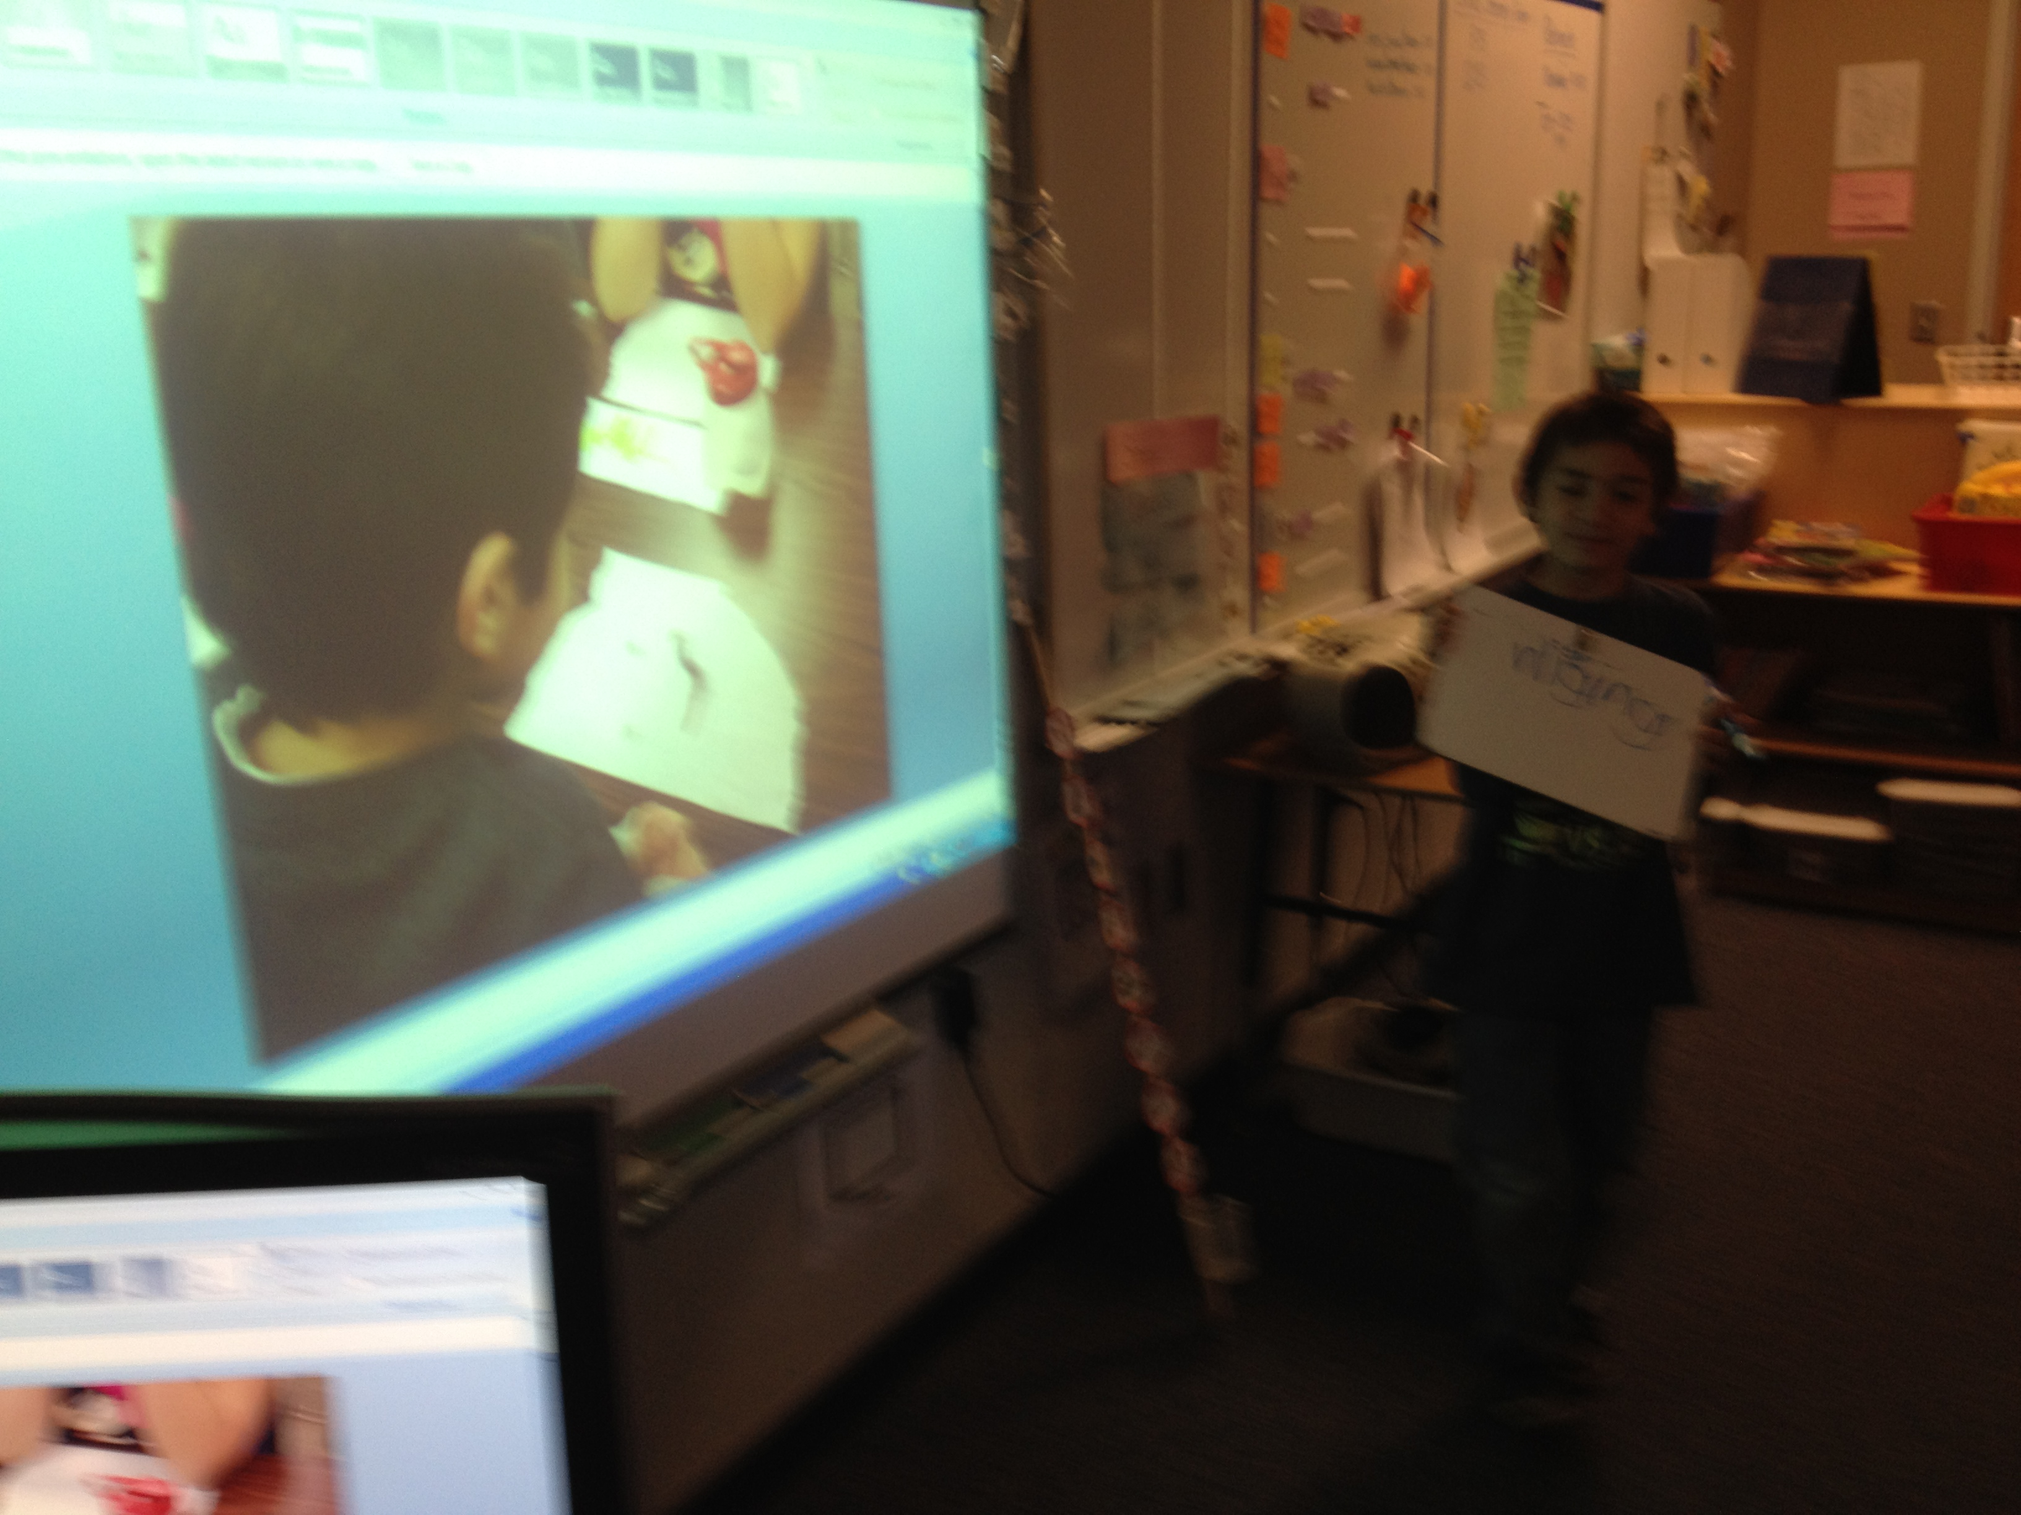
5. The students can write on a small white board what they wanted to say/write about the picture. You then write it onto the PPT. Or, students who do not want to write with a marker can use the keyboard on the computer.
6. Print out each student’s page so he/she can take it home and put it on the refrigerator!
Talking/writing about “playing with worms” activity.

